4 December 2018

Press Contact
Dr. Jürgen Krauter
Head of Communication
Nutrition & Care
Phone +49 6181 59 -6847
Fax +49 6181 59-76847
juergen.krauter@evonik.com
Specialist Press Contact
Michael Giffels
Communication
Animal Nutrition
Phone +49 6151 18 -3763
michael.giffels@evonik.com

Evonik Nutrition & Care GmbH
Rellinghauser Straße 1-11
45128 Essen
Germany
Phone +49 201 177-01
Fax +49 201 177-3475
www.evonik.com

Supervisory Board
Dr. Harald Schwager, Chairman
Managing Directors
Dr. Reiner Beste, Chairman
Dr. Hans Josef Ritzert
Michael Gattermann
Markus Schäfer

Registered office Essen
Registered court
Essen local court
Commercial registry B 25784
HR no. FN 431387 v

Evonik and Vland enter strategic cooperation

- Evonik and Vland signed a memorandum of understanding for a strategic cooperation
- Both companies will work on innovations for probiotics in animal nutrition and enzymes for industrial use
- The two parties will develop new business opportunities for probiotics in livestock, aquaculture and plant care applications

Essen. On 16 November 2018, Evonik and Vland signed a memorandum of understanding for a strategic cooperation. Both companies want to cooperate in the field of probiotics for animal nutrition and in the field of enzymes for industrial applications. In the cooperation the partners will exchange know-how, develop new products and improve process technology.

Vland, a high-tech enterprise focussing on enzymes, probiotics and animal health, provides core technology support for biological manufacturing, green solutions for food safety and also clean energy saving technology for biotech industries. In combination with Evonik’s strong global market presence and key focus on technology and application in gut health solutions, the new cooperation is expected to bring mutual benefits to both partners.

“Probiotics are already a cornerstone of our gut health solution program, and now together with Vland we believe we can develop this even further,” says Dr. Emmanuel Auer, head of Evonik’s Animal Nutrition Business Line. “We know the challenges our customers face, we understand the physiology of the animals, and have decades of experience in animal nutrition which will complement Vland’s technological innovations.”

“Vland always insists on striving for technological innovation and looks for opportunities to work with likeminded partners around the world to build a globalized technological innovation system. The collaboration with Evonik is part of this strategy and we anticipate excellent results that will better serve the Animal Nutrition industry across the globe,” says Aron Chen, CEO of Vland.

Both organizations share the same belief that the only way to meet the current demands for sustainable livestock farming is through adopting holistic solutions. For Evonik, this means linking data- and knowledge-based services with technical services, and at the same time ensuring the availability of a wide portfolio of feed additives for livestock farming.

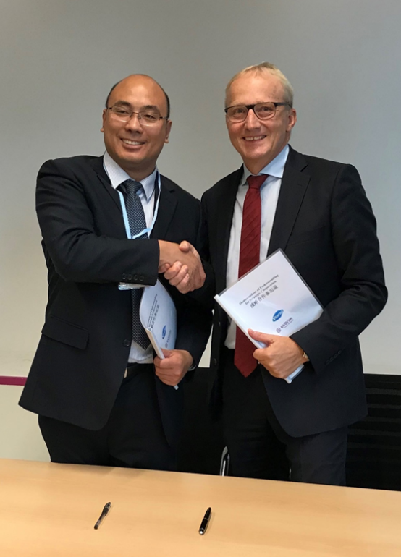

Caption: Dr. Yingjun Zhou (left), General Manager of Shandong Vland Biotech Co., Ltd., and Dr. Reiner Beste, Chairman of the Board of Management of Evonik Nutrition & Care GmbH

About Vland

Vland Biotech has been established in 2005. Headquartered in Qingdao in the Shandong Province of China, the company has a current headcount of just over 1,300 employees. Vland specializes in the research and development of four main product categories which are enzymes, probiotics, vaccines and animal health products. The company is dedicated to the provision of core technological support for bio-manufacturing, green solutions for food safety, and clean and energy-saving technologies to traditional industries. Vland is able to provide solutions to an ever-expanding list of industries including agriculture, animal husbandry, textile, paper making, household cleaning and detergents, food, biofuel, environmental protection and more.

About Evonik
Evonik is one of the world leaders in specialty chemicals. The focus on more specialty businesses, customer-orientated innovative prowess and a trustful and performance-oriented corporate culture form the heart of Evonik’s corporate strategy. They are the lever for profitable growth and a sustained increase in the value of the company. Evonik benefits specifically from its customer proximity and leading market positions. Evonik is active in over 100 countries around the world with more than 36,000 employees. In fiscal 2017, the enterprise generated sales of €14.4 billion and an operating profit (adjusted EBITDA) of €2.36 billion.

About Nutrition & Care
The Nutrition & Care segment is led by Evonik Nutrition & Care GmbH and contributes to fulfilling basic human needs. That includes applications for everyday consumer goods as well as animal nutrition and health care. This segment employed about 8,250 employees, and generated sales of around €4.5 billion in 2017.

Disclaimer
In so far as forecasts or expectations are expressed in this press release or where our statements concern the future, these forecasts, expectations or statements may involve known or unknown risks and uncertainties. Actual results or developments may vary, depending on changes in the operating environment. Neither Evonik Industries AG nor its group companies assume an obligation to update the forecasts, expectations or statements contained in this release.

