June 27, 2017

Contact person
Dr. Jürgen Krauter
Head of Communications
Nutrition & Care
Phone +49 6181 59-6847
Fax +49 6181 59-76847
juergen.krauter@evonik.com
Contact person specialized press
Michael Giffels
Head of Communications
Animal Nutrition
Phone +49 6181 59 3763
Fax + 49 6181 59 73763
michael.giffels@evonik.com

Evonik Nutrition & Care GmbH
Rellinghauser Straße 1-11
45128 Essen
Telefone +49 201 177-01
Fax +49 201 177-3475
Germany

www.evonik.com

Supervisory Board
Dr. Ralph Sven Kaufmann, Chairman

Management Board
Dr. Reiner Beste, Chairman
Dr. Hans Josef Ritzert
Michael Gattermann
Markus Schäfer
Registered office Essen
Registered court
Essen local court
Commercial registry B 25784
HR no. FN 431387 v

Evonik launches new service AMINOTilapia® for aquaculture

- increases production efficiency in tilapia aquaculture
- helps to formulate on ideal protein basis
- contributes to maintaining water quality

Essen. Evonik is to launch the new software tool AMINOTilapia® enabling the aquaculture industry to improve efficiency in tilapia farming through optimal feed formulation.

AMINOTilapia® calculates the ideal amino acid recommendations for different growth stages of tilapia considering various production features. The software helps nutritionists to formulate diets that optimally meet the animals’ needs and improve feed conversion rate, that is the efficiency with which animals utlize nutrients.

The tool is a step torwards modern diets that are formulated to balance amino acids and reduce excess dietary protein, which is usually the most costly component in feed. Balanced diets not only increase efficiency, but also contribute to protecting the environment thanks to a reduced nitrogen excretion.

Aquaculture is one of the fastest growing industries and tilapia is currently the second most produced fish worldwide, just after carp. The global production of farmed tilapia amounted to more than 5 million tonnes in 2015. Among different tilapia species, the most popular one is Nile Tilapia, which makes up about 75 percent of farmed tilapia in total.

To meet the increasing demand for healthy and nutritious fish, Evonik is supporting the aquaculture industry with a set of unique and reliable solutions. Evonik can build on the experience in the production of essential amino acids from over 60 years.

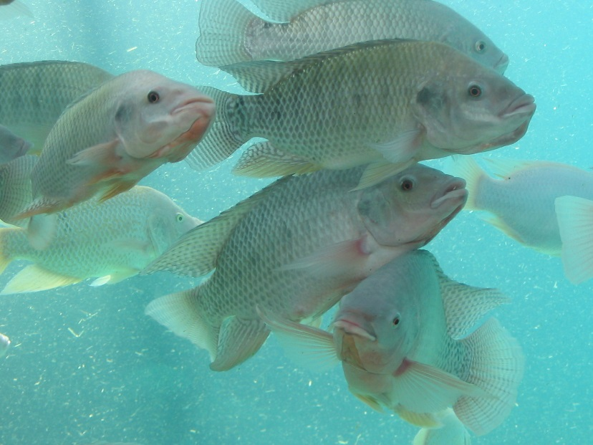
Caption:
Among different tilapia species, the most popular one is Nile Tilapia, which makes up about 75 percent of farmed tilapia in total.
© iStock / paulrdunn

Company information
Evonik is one of the world leaders in specialty chemicals. The focus on more specialty businesses, customer-orientated innovative prowess and a trustful and performance-oriented corporate culture form the heart of Evonik’s corporate strategy. They are the lever for profitable growth and a sustained increase in the value of the company. Evonik benefits specifically from its customer proximity and leading market positions. Evonik is active in over 100 countries around the world with more than 35,000 employees. In fiscal 2016, the enterprise generated sales of around €12.7 billion and an operating profit (adjusted EBITDA) of about €2.165 billion.

About Nutrition & Care
The Nutrition & Care segment is led by Evonik Nutrition & Care GmbH and contributes to fulfilling basic human needs. That includes applications for everyday consumer goods as well as animal nutrition and health care. This segment employed about 7,500 employees, and generated sales of around
€4.3 billion in 2016.

Disclaimer
In so far as forecasts or expectations are expressed in this press release or where our statements concern the future, these forecasts, expectations or statements may involve known or unknown risks and uncertainties. Actual results or developments may vary, depending on changes in the operating environment. Neither Evonik Industries AG nor its group companies assume an obligation to update the forecasts, expectations or statements contained in this release.

